**Introduction to Root Locus**

The transient response of a closed loop system is governed by the location of closed loop poles in s- plane. These poles location can easily be determined by solving the characteristics equation of the system. But when the gain of the system or any other parameter of the system changes then the characteristics equation will change. The characteristics equation need to be solved again to determine the new location of poles of system. and need to be solved again to find the location of poles. This will be tedious and control system engineer might not be able to visualize what will happen if the certain parameter of the system are changed.

Root Locus method was developed by W.R Evans that aid in visualizing the location of poles ( roots of characteristics equation ) when certain parameter of the system are changed. In root locus method the roots of the characteristics equation are plotted for all values of a system parameter. Usually the paramater used is the gain of the system.

Root locus also indicate how the open loop poles and zeros should be modified so that the response of the system meets the performance specifications.

As a control system engineer you will face many design problems. The design requrements of the system might be in terms of the damping ratio, time constant of the exponentially growing or decaying response, natural frequency of the system. Control system design problems can be tackled by root locus approach.

**Magintude and Angle Criterion (***How to check if any point is on the root locus or not***)**

Consider a closed loop system as shown in the figure below.

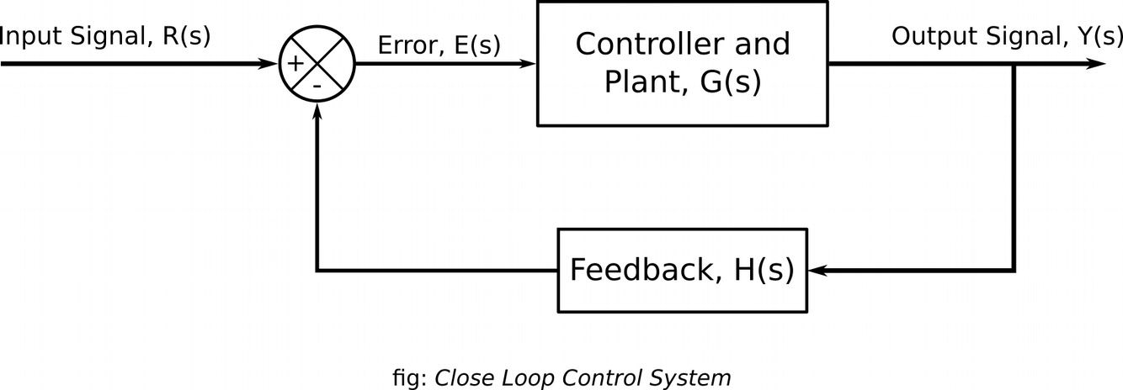

The closed loop transfer function for the system is

*C*( *s*) =

*R*( *s*)

*G*( *s*)

1 + *G*( *s* )*H* (*s* )

. The

characteristics equation of this system is 1 + *G*( *s*) *H* (*s* ) = 0

or, *G*( *s*) *H* ( *s*) = −1

G(s)H(s) is a complex quantity and a function of complex variable ‘s’. Comparing the angle and magnitude of left hand side and right hand side we can write

|*G*( *s*) *H* ( *s*)|= 1

∠ *G*( *s*) *H* ( *s*) =±180*o* (2 *k* +1) ( *k* = 0 *,* 1 *,* 2 *,* 3 ... )

The values of ‘s’ that satisfy both the angle and manitude conditions are the roots of the characteristics equation or the closed loop poles. The point in a s-plane satisfying the angle

condition alone lies in the root locus. The value of the gain corresponding to the given root can be found by using the gain criterion. Also the other roots of the characteristics equation for the given value of gain can be determined by using the magnitude criterion.